**BrowserMonkey**



**Low Level Design Document**

v 0.5

**Software House One**

Contents

Notes 2

Architectural Design 3

Tokeniser & Parser 4

Tokeniser & Tokens 4

Prototype 4

Parser 7

Renderer 8

Logging 8

Search 8

Zoom 9

Tag Interpretation Using Reflection 10

In Theory 10

In Java 10

External Files 10

Reflection 11

In the BrowserMonkey Browser 11

Pseudo Code 11

# Notes

Object diagrams need to be completed

Reflection process needs a bit of re-wording

Follow link sequence diagram need to be rescued from netbeans and inserted

Class Diagram needs some explaining.

# Architectural Design

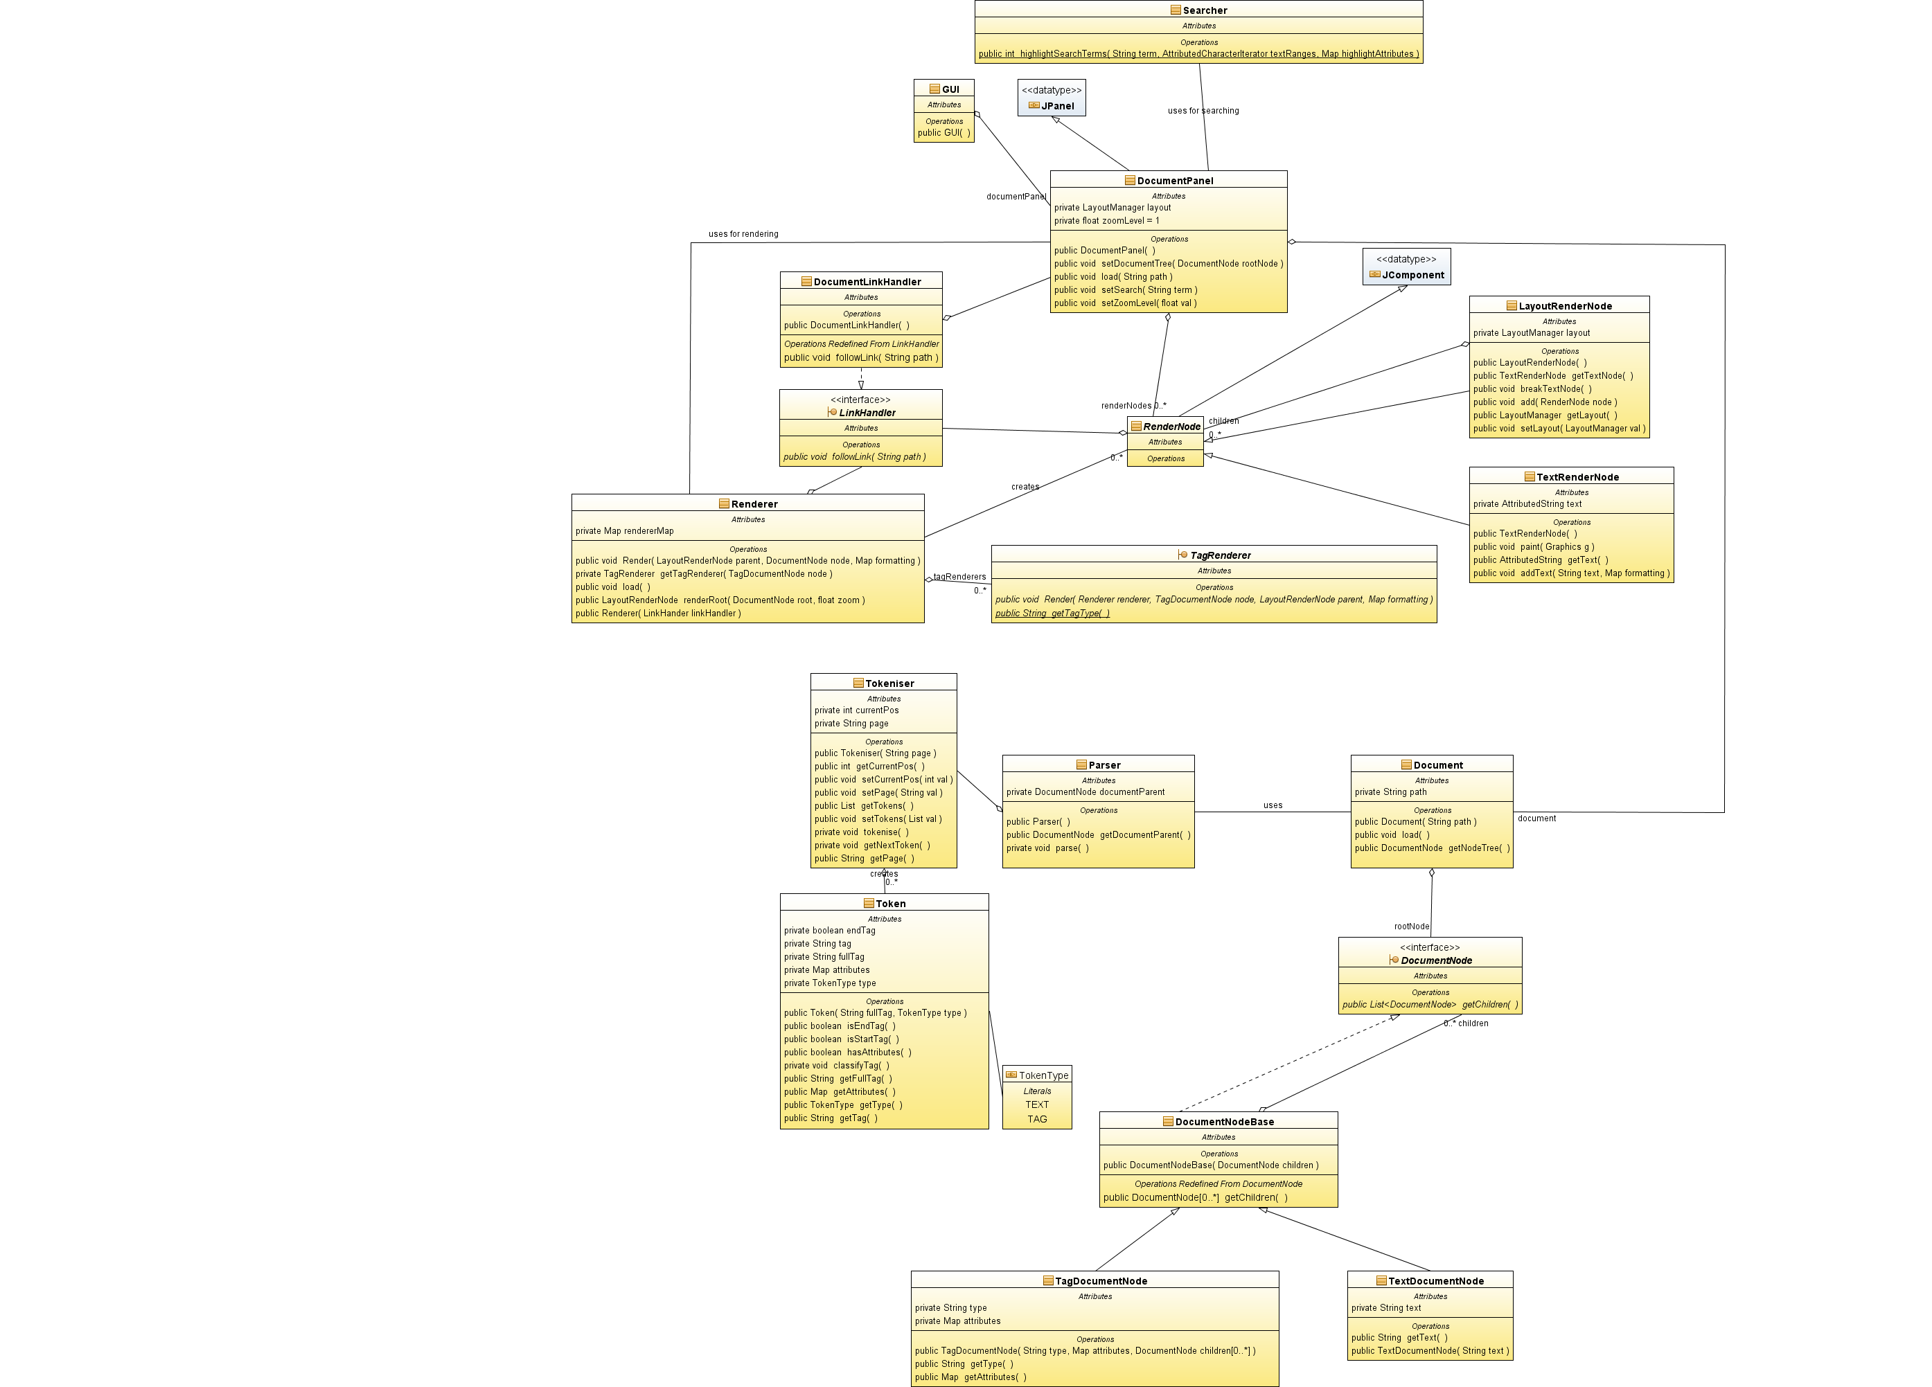

Figure : Browser Monkey Class Diagram

# Tokeniser & Parser

The tokeniser and the parser are responsible for turning a html document into a set of document nodes which can later be rendered to our surface.

## Tokeniser & Tokens

The tokeniser splits up the raw text of the html document into token object. A token object represents an atomic segment of the html. Consider the string “<b>bold</b>”: this would produce three tokens –“<b>”, “bold” and “</b>”.

### Prototype

A prototype tokeniser has been developed, using a scripting language called Ruby, to act as a proof of concept and as near- pseudocode like documentation.

**class** **MonkeyTokenizer**

#attr_reader is ruby short hand for a getter method

# so in java we'd write getPage() and getToken

attr_reader :page**,** :tokens

#in java this would be the public MonkeyTokenizer(String page){...}

**def** **initialize(**page**)**

#puts page

@current_pos **=** 0

@page **=** page**.**to_s

@tokens **=** Array**.**new #array of MonkeyTokens

tokenize

**end**

**def** **get_next_token**

**if** ?< **==** @page**[**@current_pos**]** #is this a tag

**if** @page**[(**@current_pos **+** 1**),** 3**]** **==** "!--" #is this a comment

#calculate length of token and move token

tag_token_end **=** @page**.**index**(**'-->'**,** @current_pos **+** 1**)**

raise "malformed html" **if** tag_token_end **==** **nil**

@current_pos **+=** tag**.**length

**else**

#calculate length of token and move pointer - then add to token list

tag_token_end **=** @page**.**index**(**'>'**,** @current_pos **+** 1**)**

raise "malformed html" **if** tag_token_end **==** **nil**

tag **=** @page**[**@current_pos**...**tag_token_end **+** 1**]**

@tokens **<<** MonkeyToken**.**new**(**tag**,** :tag**)**

@current_pos **+=** tag**.**length

**end**

**else**

#calculate length of text and move pointer - then add to token list

text_token_end **=** @page**.**index**(**'<'**,** @current_pos**)**

text **=** @page**[**@current_pos**...**text_token_end**]**

@tokens **<<** MonkeyToken**.**new**(**text**,** :text**)**

@current_pos **+=** text**.**length

**end**

**end**

**def** **tokenize**

**while** @current_pos **<** @page**.**length

get_next_token

**end**

**end**

**end**

**class** **MonkeyToken**

attr_reader :full_tag**,** :tag**,** :attributes**,** :type

**def** **initialize(**full_tag**,** type**)**

#@variables are class variables

#<b>

@full_tag **=** full_tag

#:text or :tag

@type **=** type

#:foo => "bar"

@attributes **=** Hash**.**new

@end_tag **=** **false**

# grab the tag name of the tag, if it's text then just keep the whole thing

@tag **=** full_tag **if** type **==** :text

**if** type **==** :tag

#regex to get the a in <a href="b">

@tag **=** full_tag**.**scan**(**/[\w:-]+/**)[**0**]**

**if** @tag**.**nil?

raise "Error, tag is nil: **#{**@full_tag**}**"

**end**

classify_tag

**end**

**end**

**def** **has_attributes?**

**return** **!**@attributes**.**empty?

**end**

**def** **is_end_tag?**

**return** @end_tag

**end**

**def** **is_start_tag?**

**return** **!**@end_tag

**end**

**def** **classify_tag**

#

# <a foo="test" bar="test" >

# produces three results: 1)a 2.1)foo 2.2)test 3.1)bar 3.2)test

#

# This function creates a hash of the attributes of a tag and determines if this tag is an end tag

#

# 'scan' breaks up a string based on a regex, with each group being a new element in an array. Sounds like hassle in java.

atts **=** @full_tag**.**scan**(**/<[\w:-]+\s+(.*)>/**)**

attr_arr **=** atts**[**0**].**to_s**.**scan**(**/\s*([\w:-]+)(?:\s*=\s*("[^"]*"|'[^']*'|([^"'>][^\s>]*)))?/m**)**

#this is a bit like a for each loop

attr_arr**.**each **do** **|**n**|**

@attributes**[**n**[**0**].**downcase**]** **=** n**[**1**]**

**end**

#determine if the tag is an end tag by looking for a / before the tag name ( </b> )

end_tag **=** @full_tag**.**index**(**'/'**,** 0**)**

**if** end_tag **!=** **nil**

tag_pos **=** @full_tag**.**index**(**@tag**,** 0**)**

@end_tag **=** **true** **if** end_tag **<** tag_pos

**end**

**end**

**end**

#little test and usage demo, feel free to butcher.

page **=** "<b>test</b><strong class='fakeBold' test='foo'>bold</strong>"

tokenizer **=** MonkeyTokenizer**.**new**(**page**)**

tokenizer**.**tokens**.**each **do** **|**n**|**

**if** n**.**type **==** :tag

string **=** "start_tag: " **if** n**.**is_start_tag?

string **=** "end_tag: " **if** n**.**is_end_tag?

string **<<** n**.**tag

**if** n**.**has_attributes?

n**.**attributes**.**each_pair **{|**key**,** value**|** string **<<** " with attrubute: **#{**key**}** is **#{**value**}**" **}**

**end**

puts string

**end**

puts "text:" **+** n**.**tag **if** n**.**type **==** :text

**end**

This code is able to correctly split up tokens and identify attributes. If provided with the text string "<b>test</b><strong class='fakeBold' test='foo'>bold</strong>"

then it produces the output:

start_tag: b

text:test

end_tag: b

start_tag: strong with attrubute: class is 'fakeBold' with attrubute: test is 'foo'

text:bold

end_tag: strong

The tokeniser works by keeping a counter of it’s position in the string to be evaluated then stepping though. If it sees a ‘<’ then it checks forward to the next “>” and assumes that to be a tag type token (unless it’s a comment). It then produces a new token object. A token object is able to be passes a string like “<foo att=’bar’>” and correctly identify that:

1. It’s a start tag
2. It’s a foo tag
3. It has an attribute “att” with the value “bar”

Each token object is kept by the tokeniser in a list. Although not demonstrated in this prototype, the tokeniser must also perform basic syntactic error correction – that is to say that the tokeniser must be able to correct “bad” html where tags are not closed or invalid symbols are present.

## Parser

The parser takes a stream of tokens from the tokeniser and applies a set of rules on those tokens. It then produces a list of DocumentNodes of various types. The parser checks that:

1. Each element is an element type we can render
2. Each element is correctly nested in appropriate elements
3. Each element has valid attributes
4. Each element correctly terminates

CODE OR PROTOTYPE HERE

# Renderer

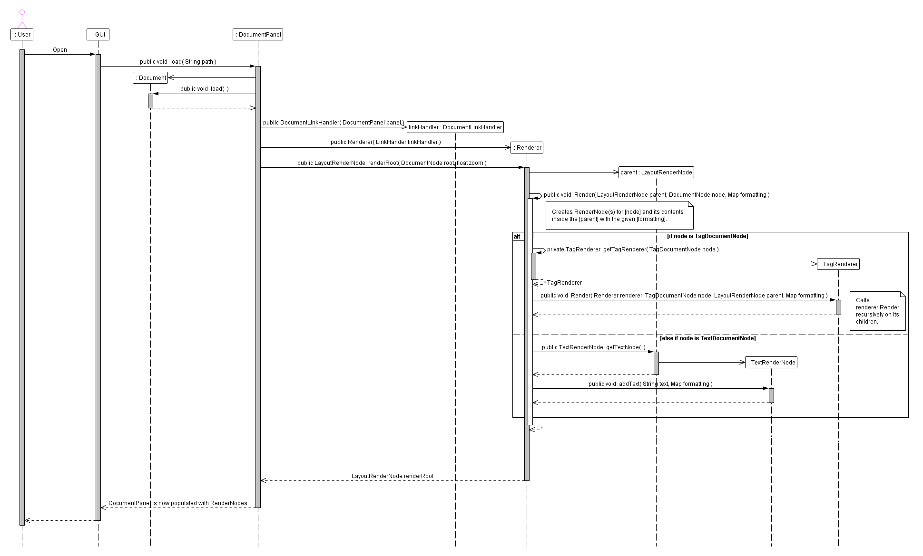

Figure : Viewing the Manual

Above is the sequence diagram for the rendering process – this diagram, for sake of brevity, omits the tokeizer and parser segments. The renderer remains largely unchanged from the high level design.

# Logging

Java provides a built in logging tool which is able to write well formatted and time stamped logs to a file of our choosing. A thin static wrapper called BrowserMonkeyLogger will be produced that will allow the programmer – from anywhere that the utilities classes have been imported – to write to the log at a given level of severity: ranging from info to fatal error.

# Search

Searching is one of the areas where there is some change from the high level design. Due to the built in java API we’re using in the Document panel, which enables highlighting on the view level, there is no longer a need to split up render nodes and we previously thought.

The blow sequence diagram illustrates the steps that are required.

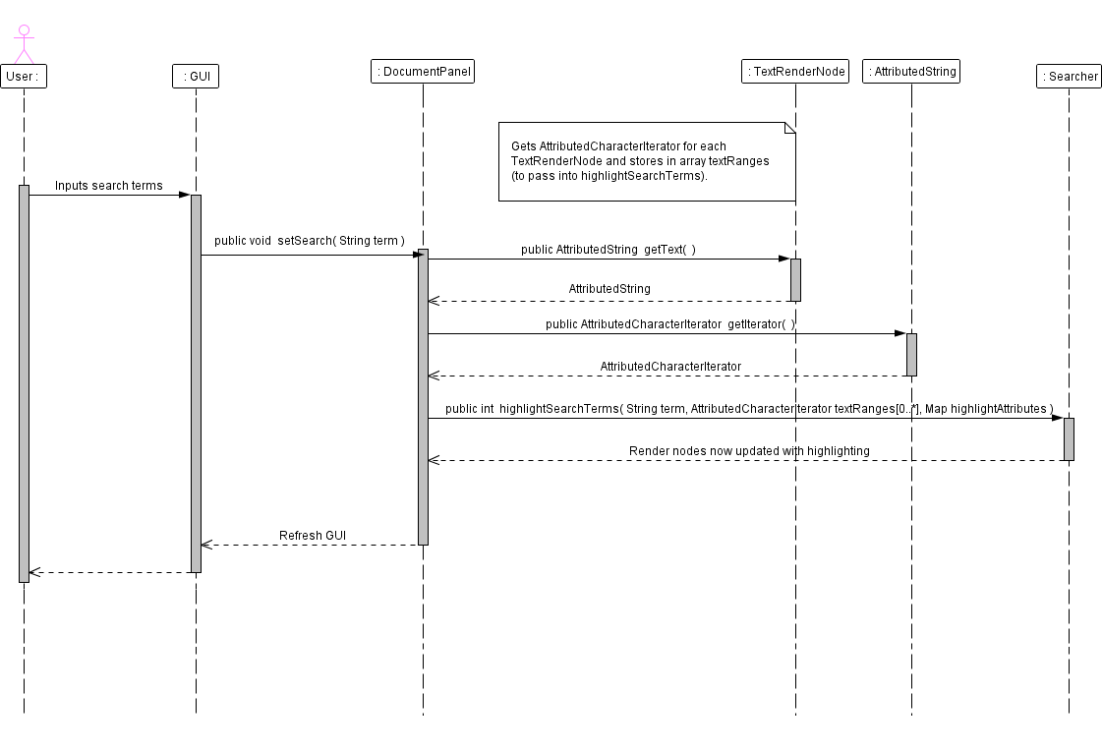

Figure Sequence Diagram of Search

# Zoom

Zoom is unchanged from the low level design. The renderer simply re-renders with a new zoom level. When a fresh page is rendered without a zoom level – we actually set the internal zoom level to 100%.

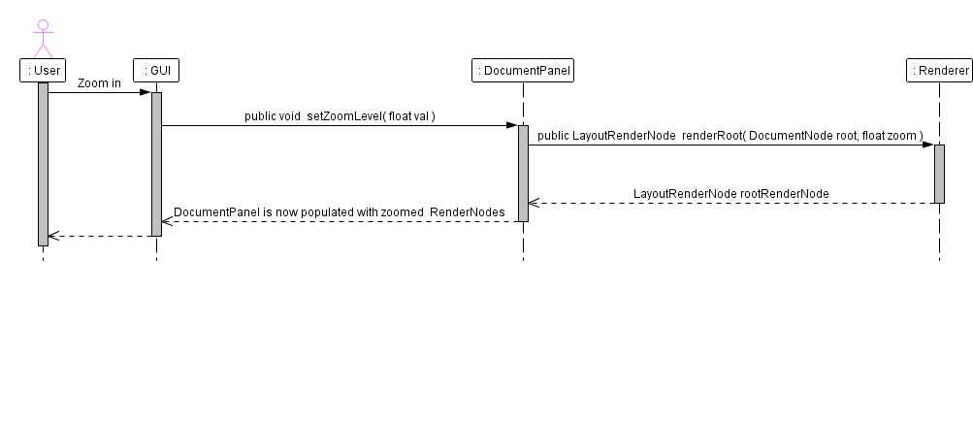

Figure Zoom Sequence Diagram

# Tag Interpretation Using Reflection

The BrowserMonkey program obviously needs to interpret a large number of tags and do this process in a modular way but most importantly efficiently. You could create a html render by just using a massive if-else statement but this would be hard to debug and horrible to reuse or update (for example to new HTML standards). This is why we have decided to use reflection.

## In Theory

Using an external file (such as a config file) that is easily editable to lookup required information for use while the program is running. Another way of doing this is having the information in the file loaded into the program when is it initially run. This allows for the addition of useful modular features to a program.

“Reflection is the process by which a computer program can observe and modify its own structure and behaviour.” – Wikipedia

Reflection allows the programmer to use multiple different classes and methods in a generic way, perfect for something like html rendering where you have many different processes used to draw the code. Reflection is also very handy for creating a modular piece of software such as a tag interpreter.

Essentially when you instantiate a class using a reflection method you don’t need to know what the class is or what methods it has, the reflection implementation will have methods that will allow you to grab any methods that class has and invoke the one you need.

## In Java

Now I will attempt to give a brief introduction of how these techniques can be implemented in Java.

### External Files

To access external files in java you can use the BufferedReader class. Here is some example code:

Code:

try {

/**Read the specified file*/

BufferedReader exampleReader = new BufferedReader(new FileReader("C:\\example.txt"));

/**Separate the file by line*/

String currentLine;

while ((currentLine = exampleReader.readLine()) != null){

//Do stuff with this line

}

} catch (FileNotFoundException ex) {

System.out.println("File not found");

} catch (IOException ex){

System.out.println("IO ERROR");

}

This Code will allow you to read each line in a file and do some useful code to each line.

### Reflection

Java has a built in class for handling reflection: java.lang.reflect

Here is some code for a simple example of reflection. Code:

import java.lang.reflect.*;

public class DumpMethods {

public static void main(String args[])

{

try {

Class c = Class.forName(args[0]);

Method m[] = c.getDeclaredMethods();

for (int i = 0; i < m.length; i++)

System.out.println(m[i].toString());

}

catch (Throwable e) {

System.err.println(e);

}

}

}

This code will allow you to enter any class name into the command line arguments and then it will output a toString of each method that class contains.

## In the BrowserMonkey Browser

To apply the above methods in the BrowserMonkey Browser we should use a Class for each HTML tag that contains code that can be used for painting the component related to the current tag. Perhaps we could create an abstract class or an interface so we can make the whole process a lot more generic.

There will be an external file that we can use to relate the tag we’re looking at to the mini Tag Classes then we will be using reflection to get the necessary paint methods over to the renderer so that it can build the required component based on the tag.

### Pseudo Code

For each documentnode:

look up Tag in external file to retrieve TagClassName

Class currentTagClass = Class.forName(TagClassName)

RenderNode newRenderNode = currentTagClass.paint()

pass the RenderNode where it needs to go

More information on reflection can be found at : <http://java.sun.com/developer/technicalArticles/ALT/Reflection/>